PFM
HOTEL ADVISOR

MANUAL DE USUARIO

AUTOR: FERNANDO MÁRQUEZ ARROYO


ÍNDICE
1. HOTEL ADVISOR - REGISTRO DE USUARIOS 3
2. HOTEL ADVISOR - LOGIN DE USUARIOS 5
3. HOTEL ADVISOR - BÚSQUEDA DE HOTELES 5
4. HOTEL ADVISOR - BÚSQUEDA AVANZADA DE HOTELES 10
4.1 BÚSQUEDA TEXTUAL POR CARACTERÍSTICAS 10
4.2 BÚSQUEDA TEXTUAL POR COMENTARIOS 13
4.3 BÚSQUEDA HOTELES SIMILARES 16
5. HOTEL ADVISOR - BÚSQUEDA POIS POR HOTEL 18
6. HOTEL ADVISOR - BÚSQUEDA HOTELES POR POI 20
7. HOTEL ADVISOR - TOP HOTELS 24
7.1 MOST SCORED 24
7.2 MOST REVIEWED 25
7.3 MOST INEXPENSIVE 26
7.4 MOST SIZED 27
8. HOTEL ADVISOR - CREAR REVIEW HOTEL 28
9. HOTEL ADVISOR - MOSTRAR REVIEWS PERSONALES 30
10. HOTEL ADVISOR - MODIFICAR PREFERENCIAS USUARIO 31
11. HOTEL ADVISOR – DASHBOARDS (KIBANA) 33
11.1 TAG CLOUD PAÍSES 33
11.2 PUNTUACIÓN POR PAÍS 34
11.3 PUNTUACIÓN POR EDAD 34
11.4 MAPA GEOGRÁFICO HOTELES 35
11.5 MAPA GEOGRÁFICO POIS 35
11.6 NÚMERO DE REVIEWS POR SEMANA 36
11.7 DASHBOARD 36

1. HOTEL ADVISOR - REGISTRO DE USUARIOS

-----------------
1. Register User
2. Login User
3. Exit
-----------------
Choose Option:
1

Username:
angel

Password:
angel

Name:
Angel

Surname:
Gomez

Age:
55

Email:
angel.gomez@movistar.es

Language [es,en]:
es

Pois Min Distance (m):
0

Pois Max Distance (m):
1000

Pois Number Limit:
20

Pois Types:
[0: 'ALL', 1: 'ACCOMMO_ALPINEHUT', 2: 'ACCOMMO_CAMPING', 3: 'ACCOMMO_CARAVAN', 4: 'ACCOMMO_CHALET', 5: 'ACCOMMO_HOSTEL', 6: 'ACCOMMO_HOTEL',
7: 'ACCOMMO_MOTEL', 8: 'AMENITY_COURT', 9: 'AMENITY_FIRESTATION', 11:'AMENITY_LIBRARY', 12:'AMENITY_PLAYGROUND', 13: 'AMENITY_POLICE',
14:'AMENITY_POSTOFFICE', 15:'AMENITY_PRISON', 16: 'AMENITY_PUBLICBUILDING', 17:'AMENITY_TOWNHALL', 18:'BARRIER_BLOCKS', 19:'EDUCATION_COLLEGE',
20:'EDUCATION_NURSERY', 21:'EDUCATION_SCHOOL', 22:'EDUCATION_UNIVERSITY',23:'FOOD_BAR',24:'FOOD_BIERGARTEN',25:'FOOD_CAFE',
26:'FOOD_FASTFOOD',27: 'FOOD_ICECREAM', 28:'FOOD_PUB', 29:'FOOD_RESTAURANT',30:'HEALTH_DENTIST',31:'HEALTH_DOCTORS',32:'HEALTH_HOSPITALEMERGENCY',
33:'HEALTH_HOSPITAL',34:'HEALTH_PHARMACY',35:'HEALTH_VETERINARY',36:'LANDUSE_ALLOTMENTS',37:'LANDUSE_CONIFEROUSDECIDUOUS',38:'LANDUSE_CONIFEROUS',
39:'LANDUSE_DECIDUOUS', 40:'LANDUSE_GRASS',41:'LANDUSE_HILLS',42:'LANDUSE_MILITARY',43:'LANDUSE_QUARY',44:'LANDUSE_SCRUB',45:'LANDUSE_SWAMP',
46:'MONEY_BANK',47:'MONEY_EXCHANGE',48:'POW_BAHAI',49:'POW_BUDDHIST',50:'POW_CHRISTIAN',51:'POW_HINDU',52:'POW_ISLAMIC',53:'POW_JAIN',
54:'POW_JEWISH', 55:'POW_SHINTO', 56:'POW_SIKH',58:'POW_UNKOWN',59:'POI_CAVE',60:'POI_CRANE',61:'POI_EMBASSY',62:'POI_BUNKER',63:'POI_MINE',
64:'POI_PEAK1',65:'POI_PEAK',66:'POI_CITY',67:'POI_HAMLET',68:'POI_SUBURB',69:'POI_TOWN',70:'POI_VILLAGE',71:'POI_TOWERCOMMUNICATION',72:'POI_TOWERLOOKOUT',
73:'SHOP_ALCOHOL', 74:'SHOP_BAKERY',75:'SHOP_BICYCLE',76:'SHOP_BOOK',77:'SHOP_BUTCHER',78:'SHOP_CARREPAIR',79:'SHOP_CAR',80:'SHOP_CLOTHES',
81:'SHOP_COMPUTER',82:'SHOP_CONFECTIONERY',83:'SHOP_CONVENIENCE',84:'SHOP_COPYSHOP',85:'SHOP_DEPARTMENTSTORE',86:'SHOP_DIY',87:'SHOP_FISH',
88:'SHOP_FLORIST',89:'SHOP_GARDENCENTRE',90:'SHOP_GIFT',91:'SHOP_GREENGROCER',92:'SHOP_HAIRDRESSER',93:'SHOP_HEARINGAIDS',94:'SHOP_HIFI',
95:'SHOP_JEWELRY', 96:'SHOP_KIOSK',97:'SHOP_LAUNDRETTE',98:'SHOP_MARKETPLACE',99:'SHOP_PHONE',100:'SHOP_MOTORCYCLE',101:'SHOP_MUSIC',
102:'SHOP_NEWSPAPER',103:'SHOP_PET',104:'SHOP_SHOES',105:'SHOP_SUPERMARKET',106:'SHOP_TOBACCO',107:'SHOP_TOYS',108:'SHOP_VENDINGMASCHINE',
109:'SHOP_VIDEORENTAL',110:'SPORT_ARCHERY',111:'SPORT_BASEBALL', 112:'SPORT_BASKETBALL',113:'SPORT_BOWLING',114:'SPORT_CANOE',
115:'SPORT_CRICKET',116:'SPORT_DIVING',117:'SPORT_FOOTBALL',118:'SPORT_GOLF',119:'SPORT_GYM',120:'SPORT_GYMNASIUM',121:'SPORT_CLIMBING',
122:'SPORT_HORSE',123:'SPORT_ICESKATING',124:'SPORT_LEISURECENTER',125:'SPORT_MINIATURGOLF', 126:'SPORT_MOTORRACING',127:'SPORT_SHOOTING',
128:'SPORT_SKATING',129:'SPORT_SKIINGDOWNHILL',130:'SPORT_SNOOKER',131:'SPORT_SOCCER',132:'SPORT_STADIUM',133:'SPORT_SWIMMING',
134:'SPORT_TENNIS',135:'SPORT_WATERSKI',136:'SPORT_SURFING',137:'TOURIST_ARCHAELOGICAL',138:'TOURIST_ART',139:'TOURIST_ATTRACTION',
140:'TOURIST_BATTLEFIELD',141:'TOURIST_BEACH',142:'TOURIST_CASTLE',143:'TOURIST_CASTLE2',144:'TOURIST_CINEMA',145:'TOURIST_FOUNTAIN',
146:'TOURIST_INFORMATION',147:'TOURIST_MEMORIAL',148:'TOURIST_MONUMENT',149:'TOURIST_MUSEUM',150:'TOURIST_NIGHTCLUB', 151:'TOURIST_RUINS',
152:'TOURIST_THEATRE',153:'TOURIST_THEMEPARK',156:'TOURIST_WINDMILL',157:'TOURIST_WRECK',158:'TOURIST_ZOO',159:'TRANSPORT_TERMINAL',
160:'TRANSPORT_AIRPORT',161:'TRANSPORT_BUSSTOP',162:'TRANSPORT_FUEL',163:'TRANSPORT_LIGHTHOUSE',164:'TRANSPORT_MARINA',165:'TRANSPORT_RENTALCAR',
166:'TRANSPORT_SUBWAY',167:'TRANSPORT_STATION',168:'TRANSPORT_TRAMSTOP',169:'WATER_DAM',170:'WATER_TOWER',171:'WATER_WEIR']
0

TOP Hotels Limit:
10

User: angel has been created succesfully

2. HOTEL ADVISOR - LOGIN DE USUARIOS

-----------------
1. Register User
2. Login User
3. Exit
-----------------
Choose Option:
2

Username:
angel

Password:
angel
-------------------------
1. Search Hotel
2. Advanced Search Hotel
3. Search Hotel POIs
4. Search POI Hotels
5. TOP Hotels
6. Review Hotel
7. Show User Reviews
8. Modify User Preferences
9. Logout
-------------------------
Choose Option:

3. HOTEL ADVISOR - BÚSQUEDA DE HOTELES

-------------------------
1. Search Hotel
2. Advanced Search Hotel
3. Search Hotel POIs
4. Search POI Hotels
5. TOP Hotels
6. Review Hotel
7. Show User Reviews
8. Modify User Preferences
9. Logout
-------------------------
Choose Option:
1

Select Continent:
_________________
| Continent |
|================|
| |
| Africa |
| Asia |
| Central America|
| Europe |
| North America |
| Oceania |
| South America |
Europe

Select Country:
__________________
| Country |
|=================|
| Abjasia |
| Albania |
| Andorra |
| Armenia |
| Austria |
| Azerbaijan |
| Belarus |
| Belgium |
| Bosnia |
| Bulgaria |
| Crimea |
| Croatia |
| Cyprus |
| Czechia |
| Denmark |
| Estonia |
| Faroe Islands |
| Finland |
| France |
| Georgia |
| Germany |
| Gibraltar |
| Greece |
| Greenland |
| Hungary |
| Iceland |
| Ireland |
| Italy |
| Kosovo |
| Latvia |
| Liechtenstein |
| Lithuania |
| Luxembourg |
| Macedonia |
| Malta |
| Moldova |
| Monaco |
| Montenegro |
| Netherlands |
| Norway |
| Poland |
| Portugal |
| Romania |
| Russia |
| Saint Barthelemy|
| San Marino |
| Serbia |
| Slovakia |
| Slovenia |
| Spain |
| Sweden |
| Switzerland |
| Turkey |
| Ukraine |
| United Kingdom |
Netherlands

Select City:
__________________________________
| City |
|=================================|
| Burgum |
| Polsbroek |
| 's Graveland |
| 's Gravenmoer |
| 's Gravenzande |
| 's Hertogenbosch |
| 's-Graveland |
| 's-Gravenzande |
| 's-Heerenberg |
| 's-Hertogenbosch |
| 't Zand |
| Aagtekerke |
| Aalden |
| Aalsmeer |
| Aalst |
| Aalten |
| Aardenburg |
| Aarle-Rixtel |
| Aartswoud |
| Abbekerk |
| Abcoude |
| Achterveld |
| Aduard |
| Aerdenhout |
| Afferden |
| Akersloot |
| Akkrum |
| Albergen |
| Alem |
| Alkmaar |
| Almelo |
| Almen |
| Almere |
| Almere-Stad |
| Alphen |
| Alphen Aan De Maas |
| Alphen aan den Rijn |
| Alteveer |
| Ambt - Delden |
| Ambt Delden |
| Ameland |
| America |
| Amerongen |
| Amersfoort |
| Amersfoort |
| Ammerzoden |
| Amstelveen |
| Amsterdam |
| Amsterdam |
| Amsterdam (Noord-Holland) |
| Amsterdam Noord |
| Anderen |
| Andijk |
| Ane |
| Anjum |
| Ankeveen |
...
| Zuidwolde |
| Zuidzande |
| Zuna |
| Zundert |
| Zurich |
| Zutphen |
| Zwaanshoek |
| Zwammerdam |
| Zwanenburg |
| Zwartsluis |
| Zweeloo |
| Zwiggelte |
| Zwijndrecht |
| Zwinderen |
| Zwolle |
| de Cocksdorp |
| de Koog |
| s-Heerenberg |
| ´t Zand |
Amsterdam

Select Score (0 - 10):
5+

Select Category (0 = hostel - 5 = 5*):
3+

Select Max Rate (EUR):
150

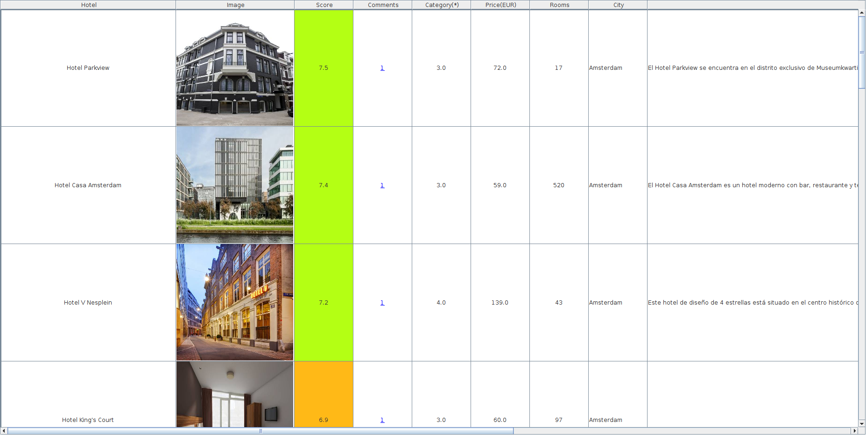

Para ver el detalle de las opiniones de un hotel, pulsar en el enlace del número de comentarios del hotel, bajo la columna “Comments”:

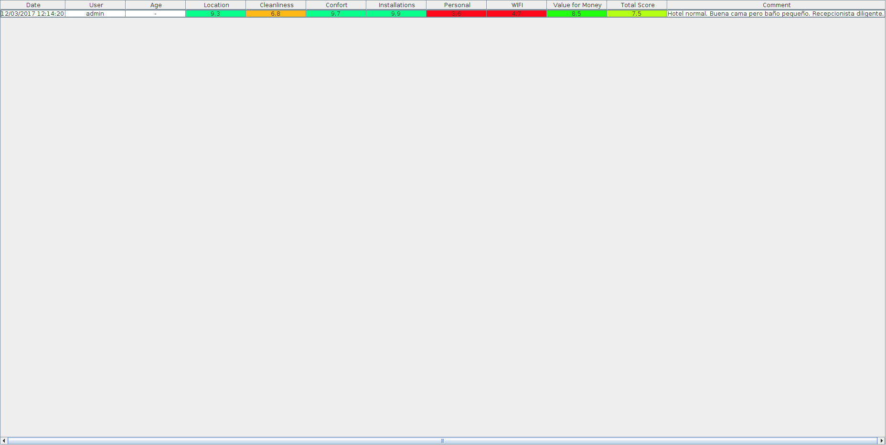

Para ver el detalle de los POIs cercanos a un hotel, basta con pulsar en el enlace "Show POIS", bajo la columna “POIs”:

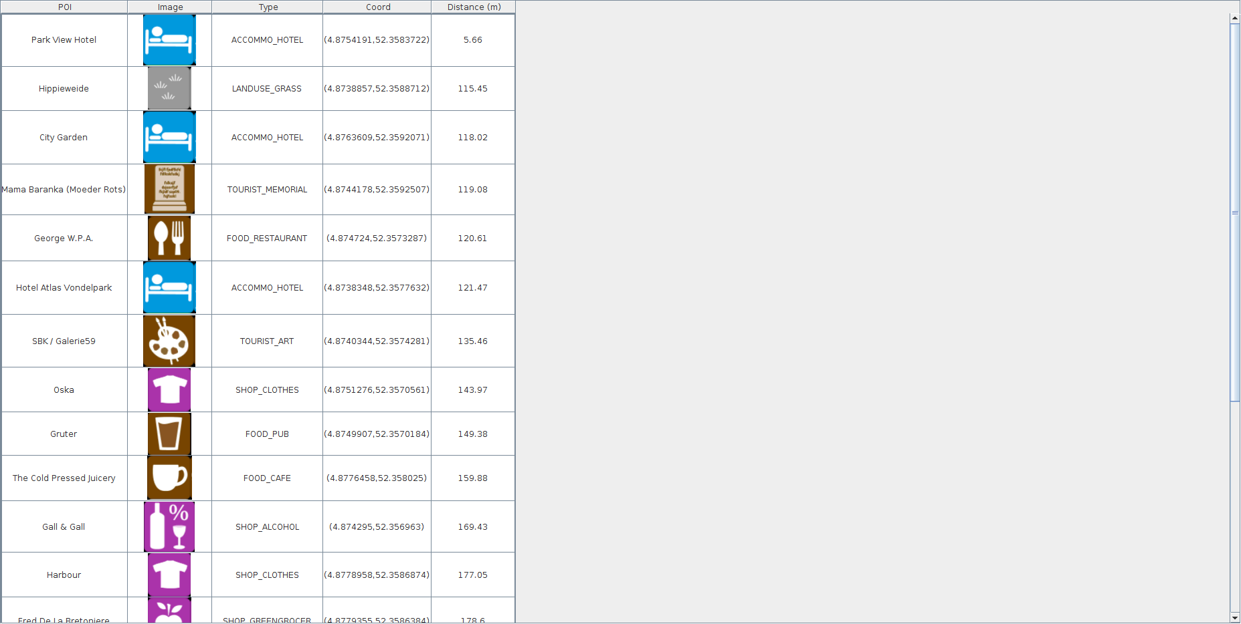

4. HOTEL ADVISOR - BÚSQUEDA AVANZADA DE HOTELES

4.1 BÚSQUEDA TEXTUAL POR CARACTERÍSTICAS

-------------------------
1. Search Hotel
2. Advanced Search Hotel
3. Search Hotel POIs
4. Search POI Hotels
5. TOP Hotels
6. Review Hotel
7. Show User Reviews
8. Modify User Preferences
9. Logout
-------------------------
Choose Option:
2

-------------------------
1. Search Hotel Features
2. Search Hotel Comments
3. Search Similar Hotels
4. Exit
-------------------------
Choose Option:
1

Select Continent:
_________________
| Continent |
|================|
| |
| Africa |
| Asia |
| Central America|
| Europe |
| North America |
| Oceania |
| South America |
Asia

Select Country:
______________________
| Country |
|=====================|
| Afghanistan |
| American Samoa |
| Bahrain |
| Bangladesh |
| Bhutan |
| Brunei |
| Cambodia |
| China |
| Hong Kong |
| India |
| Indonesia |
| Iran |
| Iraq |
| Israel |
| Japan |
| Jordan |
| Kazakhstan |
| Kuwait |
| Kyrgyzstan |
| Laos |
| Lebanon |
| Macao |
| Malaysia |
| Maldives |
| Mongolia |
| Myanmar |
| Nepal |
| Oman |
| Pakistan |
| Palestine |
| Philippines |
| Qatar |
| Saudi Arabia |
| Singapore |
| South Korea |
| Sri Lanka |
| Taiwan |
| Tajikistan |
| Thailand |
| Timor-Leste |
| United Arab Emirates|
| Uzbekistan |
| Vietnam |
Thailand

Select City:
_______________________________________________
| City |
|==============================================|
| Ban Huai Krai |
| Bang Saen |
| Bangkok 10520 |
| Chiang rai |
| KhaoLak |
| Mae-on |
| Pattaya South |
| 993-995 Ploenchit Rd. |
| Amnat Charoen |
| Amphawa |
| Amphoe Akat Amnuai |
| Amphoe Bang Saphan |
| Amphoe Chonnabot |
| Amphoe Ko Lanta |
| Amphoe Koh Samui |
| Amphoe Kumphawapi |
| Amphoe Mueang Chiang Mai |
| Amphoe Phra Khanong |
| Amphoe Sawang Daen Din |
| Amphoe Si Chiang Mai |
| Ang Sila |
| Angthong |
| Ao Luk |
| Ao Luk |
| Ao Nam Mao |
| Ao Nam Mao |
| Ao Nanag Beach |
| Ao Nang |
| Ao Nang Beach |
| Ao Nang Beach |
| Aonang |
| Aonang |
| Aonang Beach |
| Aonang beach |
| Aranyaprathet |
| Aranyaprathet |
| Ayuthaya |
| Ayutthaya |
| Baan Khai |
...
| Udon Thani |
| Udonthani |
| Uthai Thani |
| Uttaradit |
| Vieng Papao |
| Wang Nam Khieo |
| Wang Nam Khieo |
| Wang Saphung |
| Wang thong |
| Wangkata |
| Wangkata |
| Wiang Pa Pao |
| Wok Tum |
| Wok Tum |

Bangkok

Select Score (0 - 10):
6+

Select Category (0 = hostel - 5 = 5*):
0+

Select Max Rate (EUR):
90

Select Features/Terms:
piscina terraza

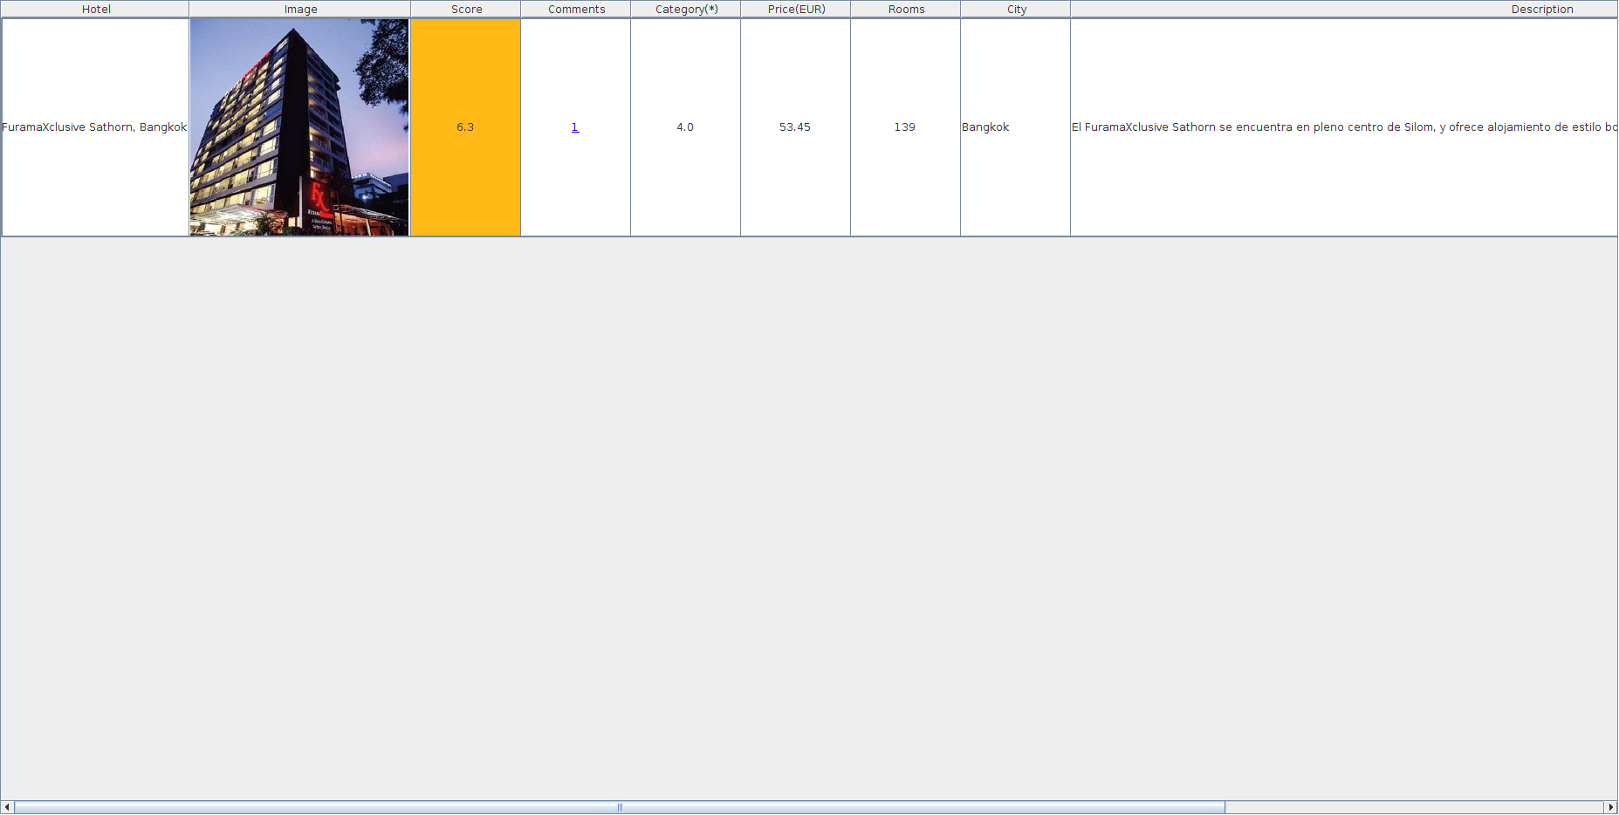

4.2 BÚSQUEDA TEXTUAL POR COMENTARIOS

-------------------------
1. Search Hotel
2. Advanced Search Hotel
3. Search Hotel POIs
4. Search POI Hotels
5. TOP Hotels
6. Review Hotel
7. Show User Reviews
8. Modify User Preferences
9. Logout
-------------------------
Choose Option:
2

-------------------------
1. Search Hotel Features
2. Search Hotel Comments
3. Search Similar Hotels
4. Exit
-------------------------
Choose Option:
2

Select Continent:
_________________
| Continent |
|================|
| |
| Africa |
| Asia |
| Central America|
| Europe |
| North America |
| Oceania |
| South America |
North America

Select Country:
___________________________
| Country |
|==========================|
| Canada |
| Mexico |
| Saint Pierre and Miquelon|
| United States of America |
United States of America

Select City:
_______________________________________________________________________
| City |
|======================================================================|
| |
| Arlington (Texas) |
| Atherton (California) |
| Florence (South Carolina) |
| Fredericksburg (Texas) |
| Idyllwild |
| Keedysville (Maryland) |
| Kissimmee |
| Marfa (Texas) |
| Menlo Park (California) |
| Moorestown (New Jersey) |

...

| Zionville (North Carolina) |
| Zumbrota (Minnesota) |
| Zuni |
| Zwolle (Louisiana) |
| lahaina (Hawaii) |
| south lake tahoe (California) |
New York

Select Score (0 - 10):
5+

Select Category (0 = hostel - 5 = 5*):
0+

Select Max Rate (EUR):
180

Select Features/Terms:
Baño

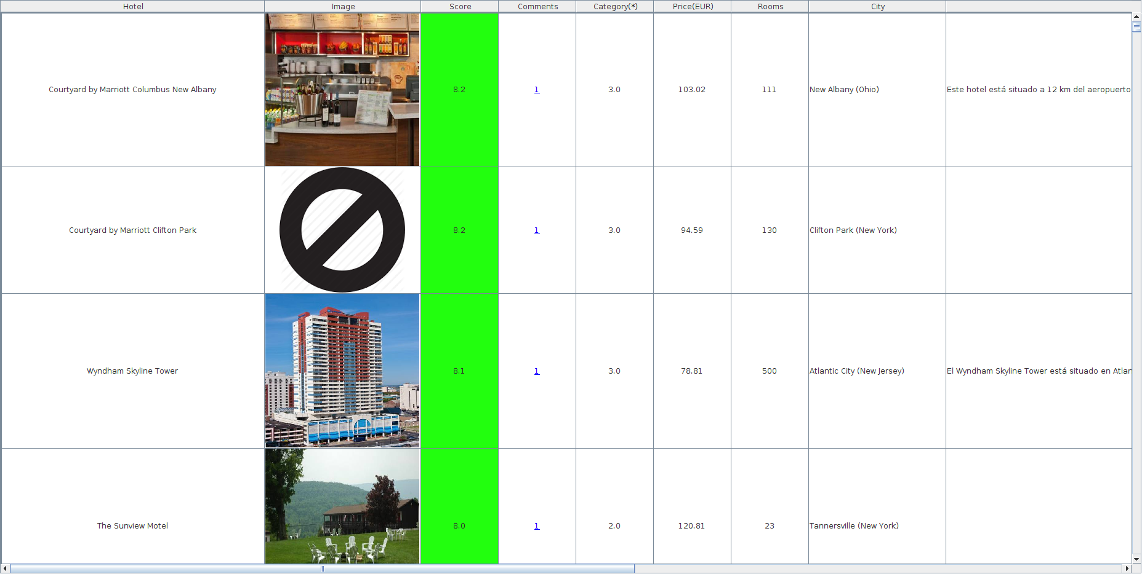

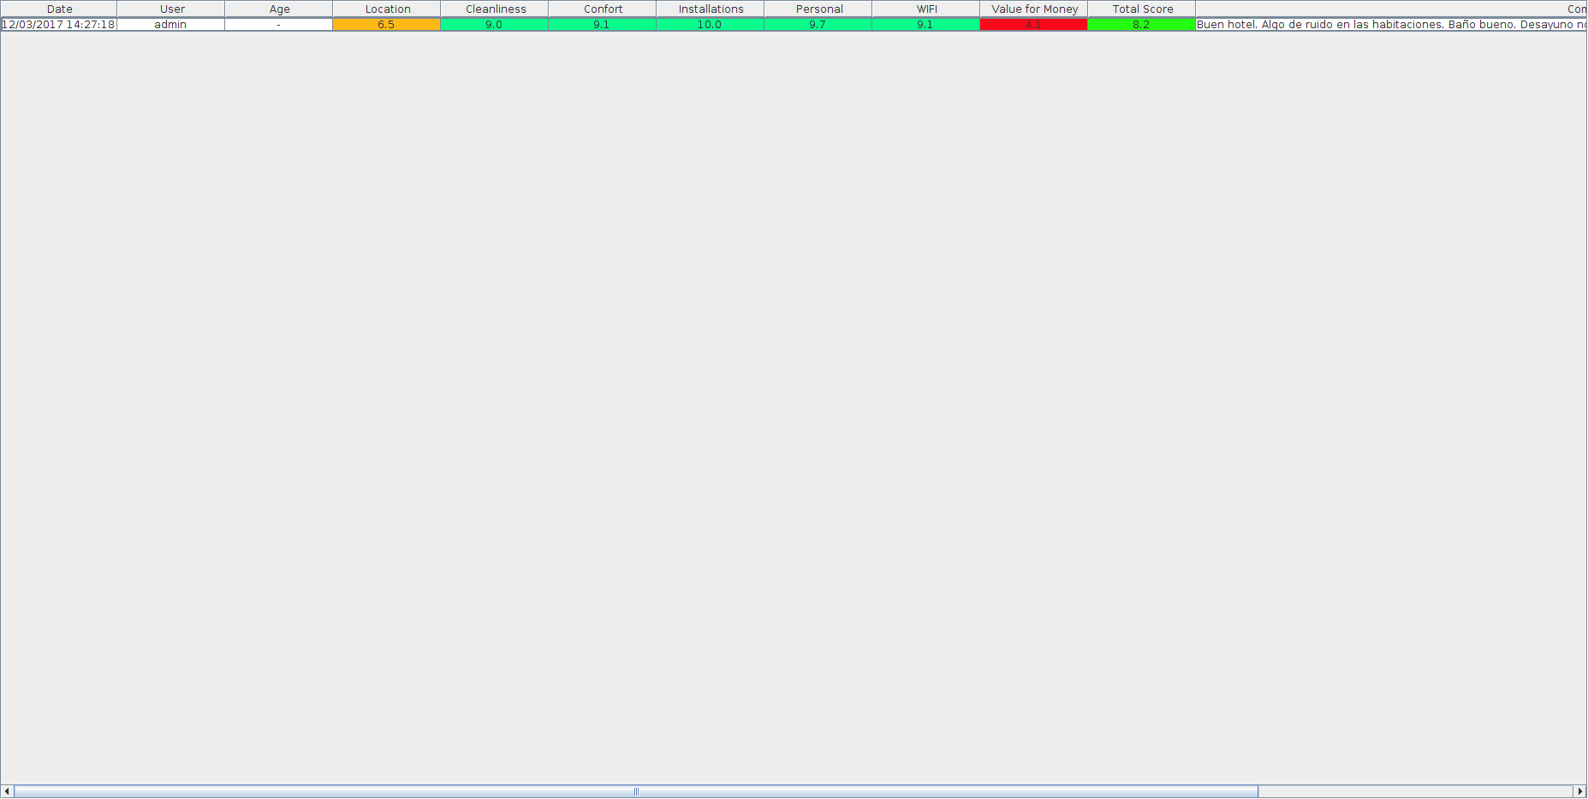

4.3 BÚSQUEDA HOTELES SIMILARES

-------------------------
1. Search Hotel
2. Advanced Search Hotel
3. Search Hotel POIs
4. Search POI Hotels
5. TOP Hotels
6. Review Hotel
7. Show User Reviews
8. Modify User Preferences
9. Logout
-------------------------
Choose Option:
2

-------------------------
1. Search Hotel Features
2. Search Hotel Comments
3. Search Similar Hotels
4. Exit
-------------------------
Choose Option:
3

Hotel name:
Intercontinental

Found 220 hotels:
____________________________________________________________________________________________________
| Hotels |
|===================================================================================================|
| 1 -> InterContinental Prague(Praha) |
| 2 -> InterContinental Berlin(Berlin) |
| 3 -> InterContinental Geneva(Geneva) |
| 4 -> InterContinental Wellington(Wellington) |
| 5 -> InterContinental Huizhou(Huizhou) |
| 6 -> InterContinental Chongqing(Chongqing) |
| 7 -> InterContinental Qingdao(Qingdao) |
| 8 -> InterContinental Cleveland(Cleveland (Ohio)) |
| 9 -> InterContinental Warszawa(Warsaw) |
| 10 -> Athenaeum Intercontinental(Athens) |
| 11 -> InterContinental Adelaide(Adelaide) |
| 12 -> InterContinental Wuhan(Wuhan) |
| 13 -> InterContinental Aqaba(Aqaba) |
| 14 -> InterContinental Hangzhou(Hangzhou) |
| 15 -> InterContinental Foshan(Foshan) |
| 16 -> InterContinental Sydney(Sydney) |
| 17 -> InterContinental Muscat(Muscat) |
| 18 -> InterContinental Jordan(Amman) |
| 19 -> InterContinental Davos(Davos) |
| 20 -> InterContinental Dallas(Dallas (Texas)) |
| 21 -> InterContinental Boston(Boston (Massachusetts)) |
| 22 -> InterContinental Santiago(Santiago) |
| 23 -> InterContinental Tangshan(Tangshan) |
| 24 -> InterContinental Shenzhen(Shenzhen) |
| 25 -> InterContinental Fuzhou(Fuzhou) |
| 26 -> InterContinental Nanjing(Nanjing) |
| 27 -> InterContinental Shijiazhuang(Shijiazhuang) |
| 28 -> InterContinental Wuxi(Wuxi) |
| 29 -> Vijay Intercontinental(Kanpur) |
| 30 -> InterContinental Estoril(Estoril) |
| 31 -> InterContinental Jeddah(Jeddah) |
| 32 -> InterContinental Almaty(Almaty) |
| 33 -> InterContinental Dalian(Dalian) |
| 34 -> InterContinental Changsha(Changsha) |
| 35 -> InterContinental Nairobi(Nairobi) |
| 36 -> InterContinental Madrid(Madrid) |
| 37 -> InterContinental Wien(Vienna) |
| 38 -> InterContinental Kiev(Kiev) |
| 39 -> InterContinental Istanbul(Istanbul) |
| 40 -> InterContinental Malta(St. Julian's) |
| 41 -> InterContinental Montreal(Montréal (Québec)) |
| 42 -> InterContinental Dublin(Dublin) |
| 43 -> InterContinental Frankfurt(Frankfurt am Main) |
| 44 -> InterContinental Budapest(Budapest) |
...
| 220 -> Baymont Inn & Suites Houston Intercontinental Airport - IAH/Humble(Humble (Texas)) |

Select Hotel Id:
44

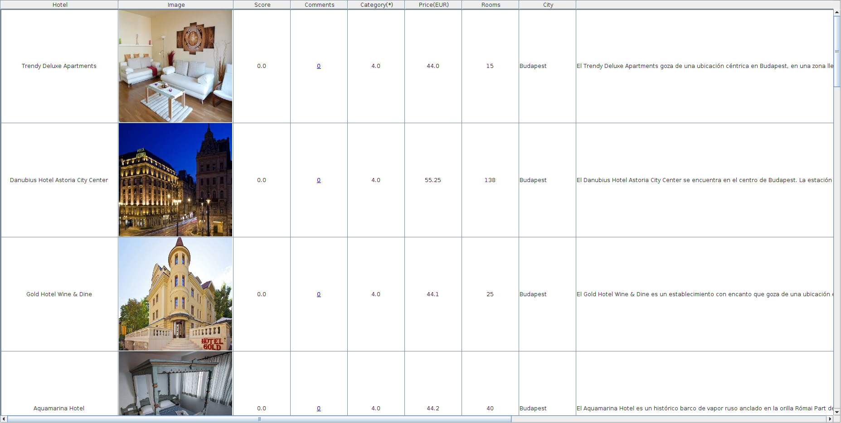

5. HOTEL ADVISOR - BÚSQUEDA POIS POR HOTEL

-------------------------
1. Search Hotel
2. Advanced Search Hotel
3. Search Hotel POIs
4. Search POI Hotels
5. TOP Hotels
6. Review Hotel
7. Show User Reviews
8. Modify User Preferences
9. Logout
-------------------------
Choose Option:
3

Hotel name:
Fresa Inn

Found 500 hotels:
______________________________________________________________________
| Hotels |
|=====================================================================|
| 1 -> Apartment Fresa(Zadar) |
| 2 -> Sotetsu Fresa Inn Fujisawa-Minamiguchi(Fujisawa) |
| 3 -> Sotetsu Fresa Inn Yokohama Totsuka(Yokohama) |
| 4 -> Sotetsu Fresa Inn Nihombashi Kayabacho(Tokyo) |
| 5 -> Sotetsu Fresa Inn Tokyo Kamata(Tokyo) |
| 6 -> Sotetsu Fresa Inn Nihombashi-Ningyocho(Tokyo) |
| 7 -> Sotetsu Fresa Inn Hamamatsucho-Daimon(Tokyo) |
| 8 -> Sotetsu Fresa Inn Tokyo-Kyobashi(Tokyo) |
| 9 -> Sotetsu Fresa Inn Chiba Kashiwa(Kashiwa) |
| 10 -> Sotetsu Fresa Inn Ginza-Nanachome(Tokyo) |
| 11 -> Sotetsu Fresa Inn Ochanomizu Jimbocho(Tokyo) |
| 12 -> Sotetsu Fresa Inn Shimbashi Hibiyaguchi(Tokyo) |
| 13 -> Sotetsu Fresa Inn Tokyo-Toyocho(Tokyo) |
| 14 -> Sotetsu Fresa Inn Fujisawa Shonandai(Fujisawa) |
| 15 -> Tenuta la Fresa(Muro Leccese) |
| 16 -> Hotel Grand Fresa Akasaka(Tokyo) |
| 17 -> La Fresa Hostel(Corralejo) |
| 18 -> Sotetsu Fresa Inn Yokohama Sakuragi-cho(Yokohama) |
| 19 -> @Inn(Yufu) |
| 20 -> Quality Inn Dutch Inn(Collinsville (Virginia)) |
...
| 500 -> Seaside Inn(Sanibel (Florida)) |

Select Hotel Id:
4
----------------------------------------------------
[Type: ACCOMMO_HOTEL] [Name: ???????? ??????][Coord: [139.77994993329,35.6807850280462][Distance (m): 11.06984538585745]

[Type: ACCOMMO_HOTEL] [Name: Keyo Presso In][Coord: [139.77994993329,35.6807850280462][Distance (m): 31.816107357560206]

[Type: SHOP_CONVENIENCE] [Name: ????????][Coord: [139.77994993329,35.6807850280462][Distance (m): 40.42200876383721]

[Type: SHOP_CONVENIENCE] [Name: 7-Eleven][Coord: [139.77994993329,35.6807850280462][Distance (m): 43.7361894666381]

[Type: SHOP_GREENGROCER] [Name: Imano Fruite Factory][Coord: [139.77994993329,35.6807850280462][Distance (m): 58.247886518373264]

[Type: POW_BUDDHIST] [Name: ???][Coord: [139.77994993329,35.6807850280462][Distance (m): 61.61420387952136]

[Type: AMENITY_PUBLICBUILDING] [Name: SSS70???][Coord: [139.77994993329,35.6807850280462][Distance (m): 62.38241945875283]

[Type: FOOD_FASTFOOD] [Name: ???][Coord: [139.77994993329,35.6807850280462][Distance (m): 63.325270027943276]

[Type: TRANSPORT_BUSSTOP] [Name: ???][Coord: [139.77994993329,35.6807850280462][Distance (m): 73.82652009580727]

[Type: POW_SHINTO] [Name: ?? ????][Coord: [139.77994993329,35.6807850280462][Distance (m): 89.31973223990244]

[Type: TRANSPORT_BUSSTOP] [Name: ???][Coord: [139.77994993329,35.6807850280462][Distance (m): 89.73263971275269]

[Type: TRANSPORT_SUBWAY] [Name: ???][Coord: [139.77994993329,35.6807850280462][Distance (m): 94.38787666714119]

[Type: POW_SHINTO] [Name: ??????][Coord: [139.77994993329,35.6807850280462][Distance (m): 95.00290398045851]

[Type: SHOP_CONVENIENCE] [Name: ???-????][Coord: [139.77994993329,35.6807850280462][Distance (m): 95.74977349649464]

[Type: SHOP_PHONE] [Name: ???????][Coord: [139.77994993329,35.6807850280462][Distance (m): 103.56050588051313]

[Type: FOOD_CAFE] [Name: ????????][Coord: [139.77994993329,35.6807850280462][Distance (m): 115.44961746940015]

[Type: FOOD_RESTAURANT] [Name: ????????][Coord: [139.77994993329,35.6807850280462][Distance (m): 141.69211186411604]

[Type: FOOD_CAFE] [Name: ???·?·???][Coord: [139.77994993329,35.6807850280462][Distance (m): 142.27606101803354]

[Type: SHOP_CONVENIENCE] [Name: ???-????][Coord: [139.77994993329,35.6807850280462][Distance (m): 143.0877929650974]

[Type: FOOD_FASTFOOD] [Name: ???????][Coord: [139.77994993329,35.6807850280462][Distance (m): 145.79150502248916]

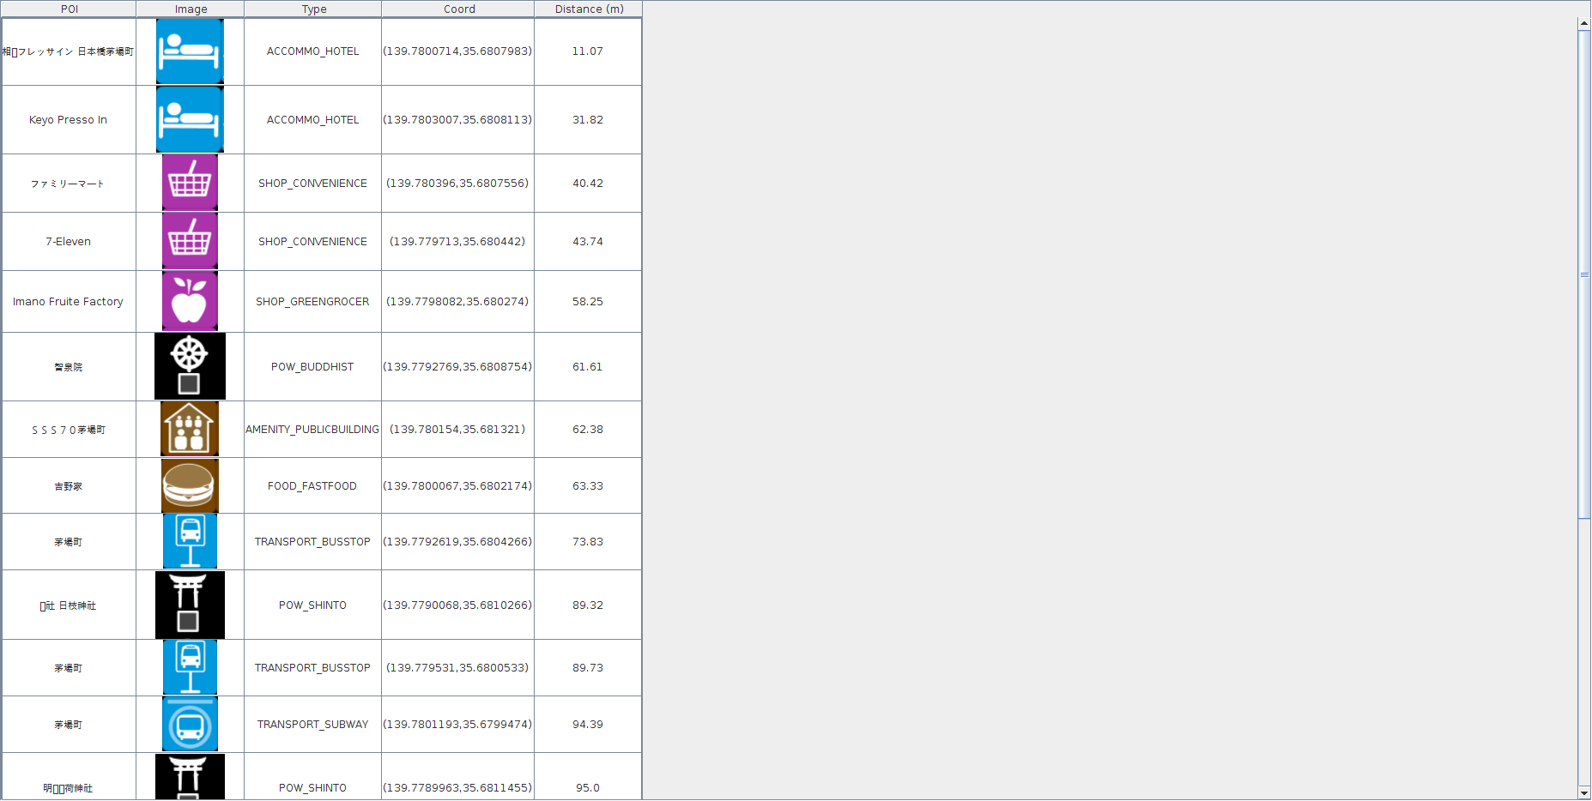

6. HOTEL ADVISOR - BÚSQUEDA HOTELES POR POI

-------------------------
1. Search Hotel
2. Advanced Search Hotel
3. Search Hotel POIs
4. Search POI Hotels
5. TOP Hotels
6. Review Hotel
7. Show User Reviews
8. Modify User Preferences
9. Logout
-------------------------
Choose Option:
4

POI name:
Giza

Found 17 pois:
____________________________________________________
| POIs |
|===================================================|
| 1 -> Giza(FOOD_BAR) |
| 2 -> Giza(FOOD_PUB) |
| 3 -> Giza(POI_VILLAGE) |
| 4 -> Giza(FOOD_BAR) |
| 5 -> Giza(POI_HAMLET) |
| 6 -> GIZA(FOOD_RESTAURANT) |
| 7 -> Giza Kebab(FOOD_FASTFOOD) |
| 8 -> Giza Center(SHOP_SUPERMARKET) |
| 9 -> Suwa Giza(POI_HAMLET) |
| 10 -> Giza Entrance(TOURIST_ATTRACTION) |
| 11 -> Giza Plaza Dügün Salonu(TOURIST_THEATRE) |
| 12 -> Mwembe giza primary school(EDUCATION_SCHOOL)|
| 13 -> Sunway Giza Shopping Mall(SHOP_SUPERMARKET) |
| 14 -> Giza Eskubideen Plaza(TOURIST_FOUNTAIN) |
| 15 -> Giza National Automotive(SHOP_CARREPAIR) |
| 16 -> Giza eskubideen parkea(LANDUSE_GRASS) |
| 17 -> La rosa di Giza(SHOP_HAIRDRESSER) |

Select Poi Id:
10

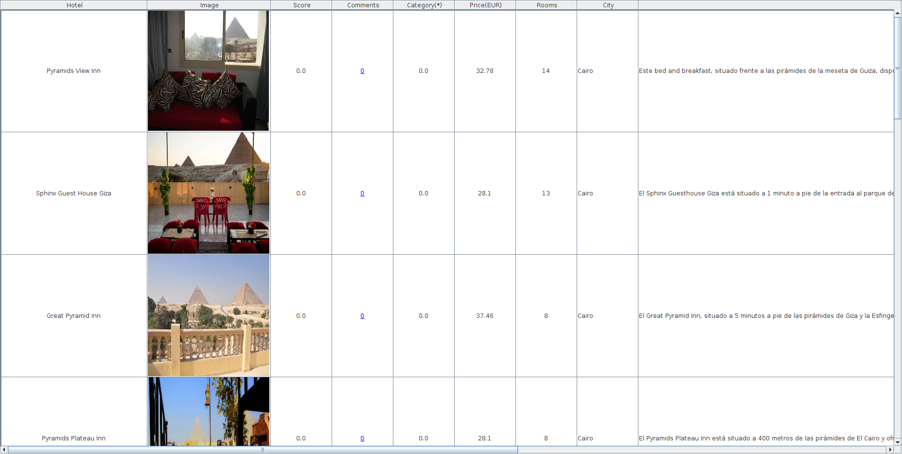

-------------------------
1. Search Hotel
2. Advanced Search Hotel
3. Search Hotel POIs
4. Search POI Hotels
5. TOP Hotels
6. Review Hotel
7. Show User Reviews
8. Modify User Preferences
9. Logout
-------------------------
Choose Option:
4

POI name:
Sydney Opera

Found 50 pois:
_____________________________________________________
| POIs |
|====================================================|
| 1 -> Sydney Opera House(TOURIST_THEATRE) |
| 2 -> Sydney Opera House(TOURIST_ATTRACTION) |
| 3 -> Handa Opera on Sydney Harbour(TOURIST_THEATRE)|
| 4 -> Sydney(FOOD_RESTAURANT) |
| 5 -> Sydney(FOOD_RESTAURANT) |
| 6 -> Sydney(POI_VILLAGE) |
| 7 -> Sydney(SHOP_CLOTHES) |
| 8 -> Sydney(HEALTH_PHARMACY) |
| 9 -> Sydney(SHOP_HAIRDRESSER) |
| 10 -> Sydney(FOOD_BAR) |
| 11 -> Sydney(SHOP_CONVENIENCE) |
| 12 -> Sydney(POI_HAMLET) |
| 13 -> Sydney(FOOD_RESTAURANT) |
| 14 -> Sydney(POI_CITY) |
| 15 -> Sydney(POI_CITY) |
| 16 -> Sydney(POI_SUBURB) |
| 17 -> opera(ACCOMMO_HOSTEL) |
| 18 -> OPERA(FOOD_CAFE) |
| 19 -> Opera(TOURIST_NIGHTCLUB) |
| 20 -> Opera(TRANSPORT_BUSSTOP) |
| 21 -> Opera(FOOD_CAFE) |
| 22 -> opera(ACCOMMO_HOSTEL) |
| 23 -> Opera(FOOD_CAFE) |
| 24 -> Opera(FOOD_RESTAURANT) |
| 25 -> Opera(FOOD_RESTAURANT) |
| 26 -> Opera(FOOD_CAFE) |
| 27 -> Opera(SHOP_BICYCLE) |
| 28 -> Opera(FOOD_CAFE) |
| 29 -> OPERA(FOOD_CAFE) |
| 30 -> Opera(FOOD_ICECREAM) |
| 31 -> Opera(TRANSPORT_BUSSTOP) |
| 32 -> Opera(ACCOMMO_HOTEL) |
| 33 -> Opera(TOURIST_THEATRE) |
| 34 -> Opera(FOOD_PUB) |
| 35 -> Opera(FOOD_CAFE) |
| 36 -> Opera(FOOD_RESTAURANT) |
| 37 -> Opera(TRANSPORT_TRAMSTOP) |
| 38 -> Opera(TOURIST_NIGHTCLUB) |
| 39 -> Opera(POI_TOWN) |
| 40 -> Opera(FOOD_CAFE) |
| 41 -> Opera(TRANSPORT_BUSSTOP) |
| 42 -> Opera(ACCOMMO_HOTEL) |
| 43 -> Opera(FOOD_RESTAURANT) |
| 44 -> Opera(TRANSPORT_BUSSTOP) |
| 45 -> Opera(SHOP_CLOTHES) |
| 46 -> Opera(FOOD_CAFE) |
| 47 -> Opera(SHOP_CLOTHES) |
| 48 -> Opera(TOURIST_NIGHTCLUB) |
| 49 -> Opera(FOOD_RESTAURANT) |
| 50 -> Opera(SHOP_SUPERMARKET) |

Select Poi Id:
1

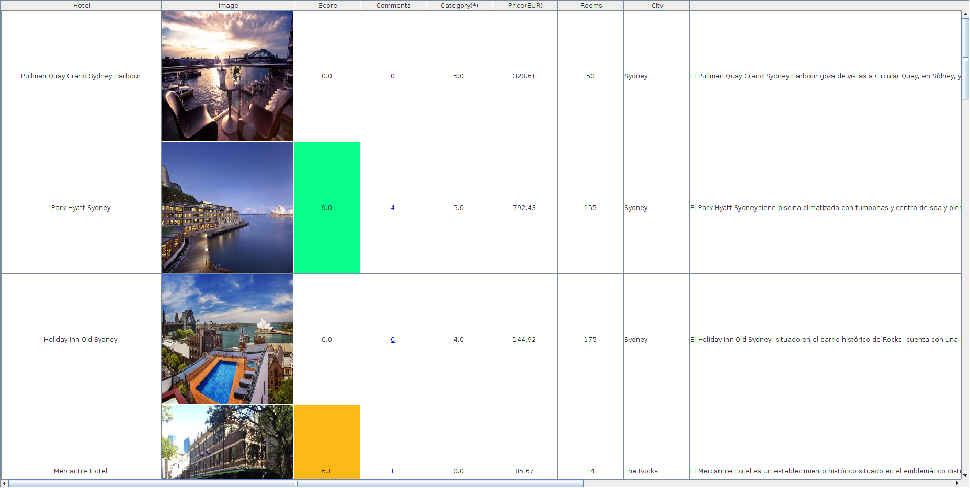
-------------------------
1. Search Hotel
2. Advanced Search Hotel
3. Search Hotel POIs
4. Search POI Hotels
5. TOP Hotels
6. Review Hotel
7. Show User Reviews
8. Modify User Preferences
9. Logout
-------------------------
Choose Option:
4

POI name:
Mestalla

Found 2 pois:
_______________________________________
| POIs |
|======================================|
| 1 -> Mestalla(FOOD_RESTAURANT) |
| 2 -> Estadi de Mestalla(SPORT_SOCCER)|

Select Poi Id:
2

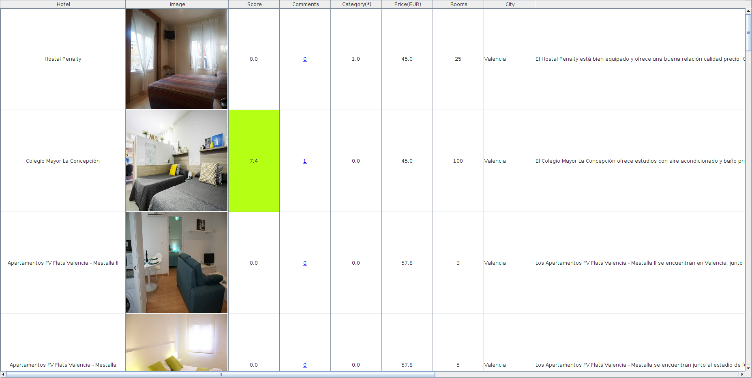

7. HOTEL ADVISOR - TOP HOTELS

7.1 MOST SCORED

-------------------------
1. Search Hotel
2. Advanced Search Hotel
3. Search Hotel POIs
4. Search POI Hotels
5. TOP Hotels
6. Review Hotel
7. Show User Reviews
8. Modify User Preferences
9. Logout
-------------------------
Choose Option:
5

--------------------
1. Most Scored
2. Most Reviewed
3. Most Inexpensive
4. Most Sized
5. Exit
---------------------
Choose Option:
1
Select City:
Nairobi

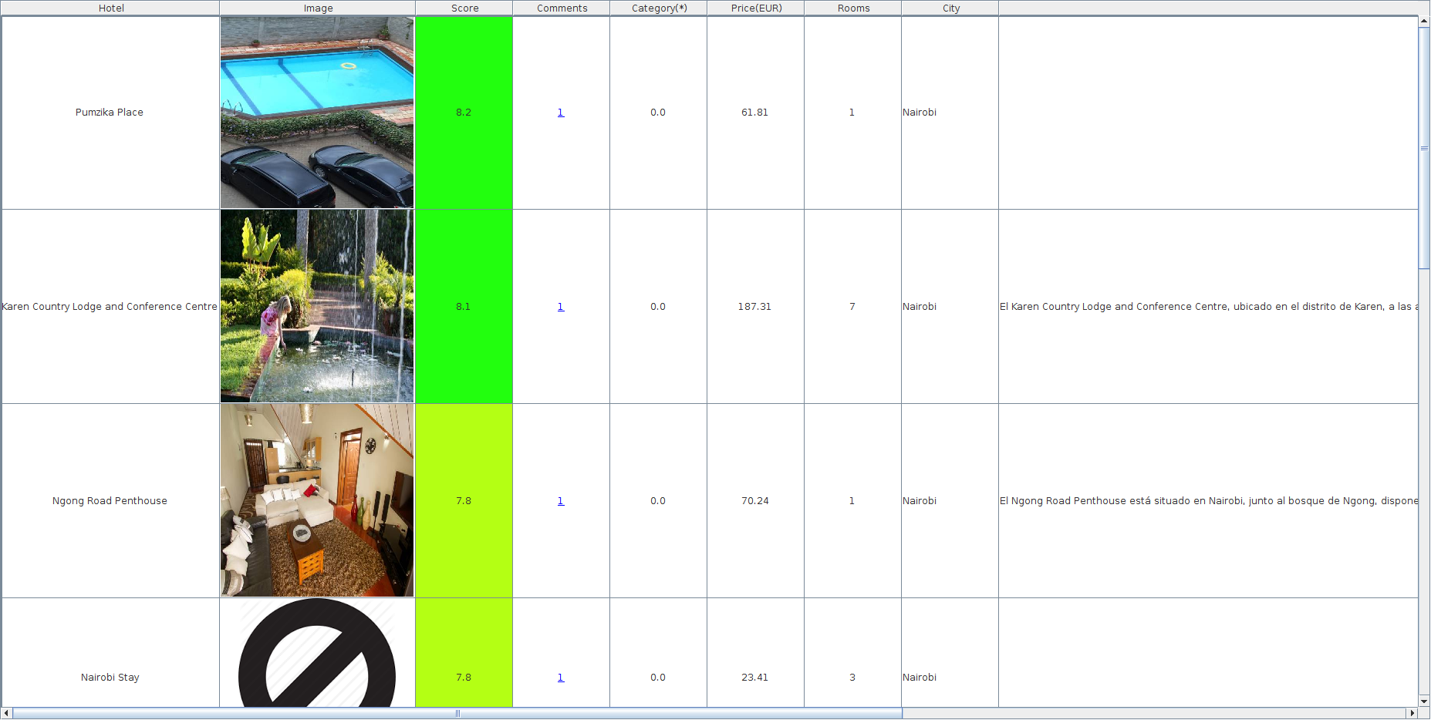

7.2 MOST REVIEWED

-------------------------
1. Search Hotel
2. Advanced Search Hotel
3. Search Hotel POIs
4. Search POI Hotels
5. TOP Hotels
6. Review Hotel
7. Show User Reviews
8. Modify User Preferences
9. Logout
-------------------------
Choose Option:
5

--------------------
1. Most Scored
2. Most Reviewed
3. Most Inexpensive
4. Most Sized
5. Exit
---------------------
Choose Option:
2
Select City:
Hong Kong

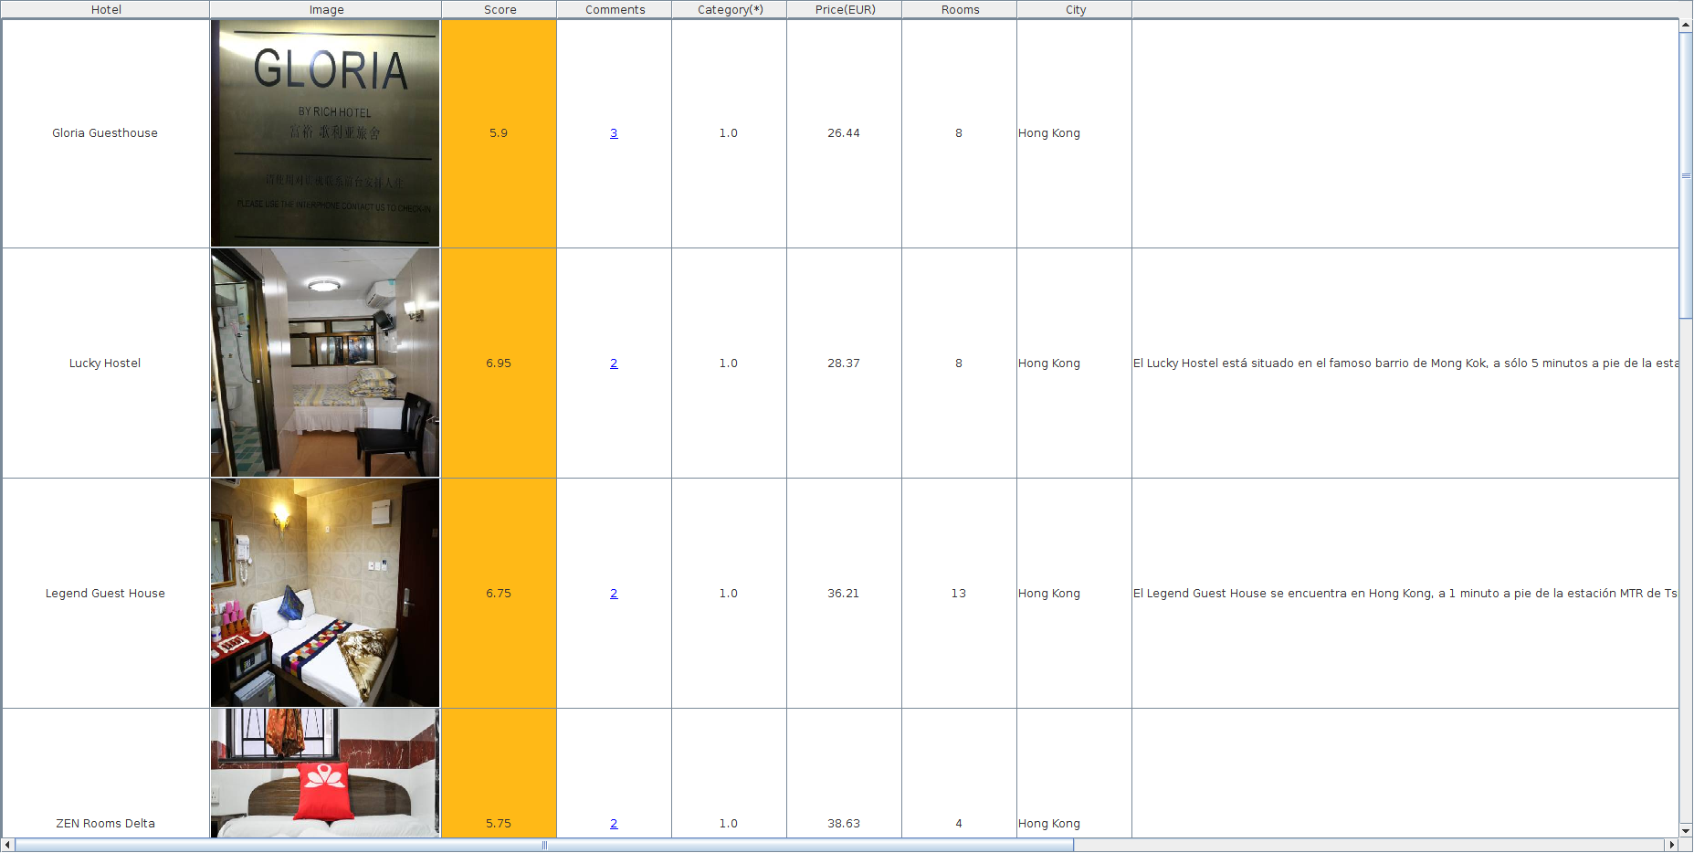

7.3 MOST INEXPENSIVE

-------------------------
1. Search Hotel
2. Advanced Search Hotel
3. Search Hotel POIs
4. Search POI Hotels
5. TOP Hotels
6. Review Hotel
7. Show User Reviews
8. Modify User Preferences
9. Logout
-------------------------
Choose Option:
5

--------------------
1. Most Scored
2. Most Reviewed
3. Most Inexpensive
4. Most Sized
5. Exit
---------------------
Choose Option:
3
Select City:
Bogota

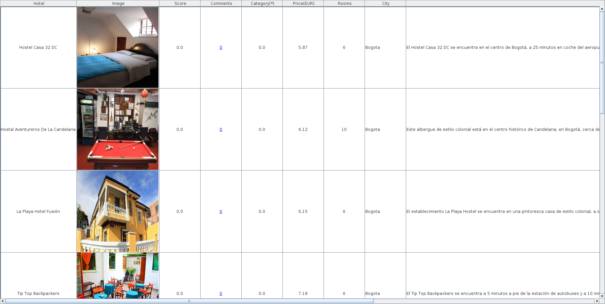

7.4 MOST SIZED

-------------------------
1. Search Hotel
2. Advanced Search Hotel
3. Search Hotel POIs
4. Search POI Hotels
5. TOP Hotels
6. Review Hotel
7. Show User Reviews
8. Modify User Preferences
9. Logout
-------------------------
Choose Option:
5

--------------------
1. Most Scored
2. Most Reviewed
3. Most Inexpensive
4. Most Sized
5. Exit
---------------------
Choose Option:
4
Select City:

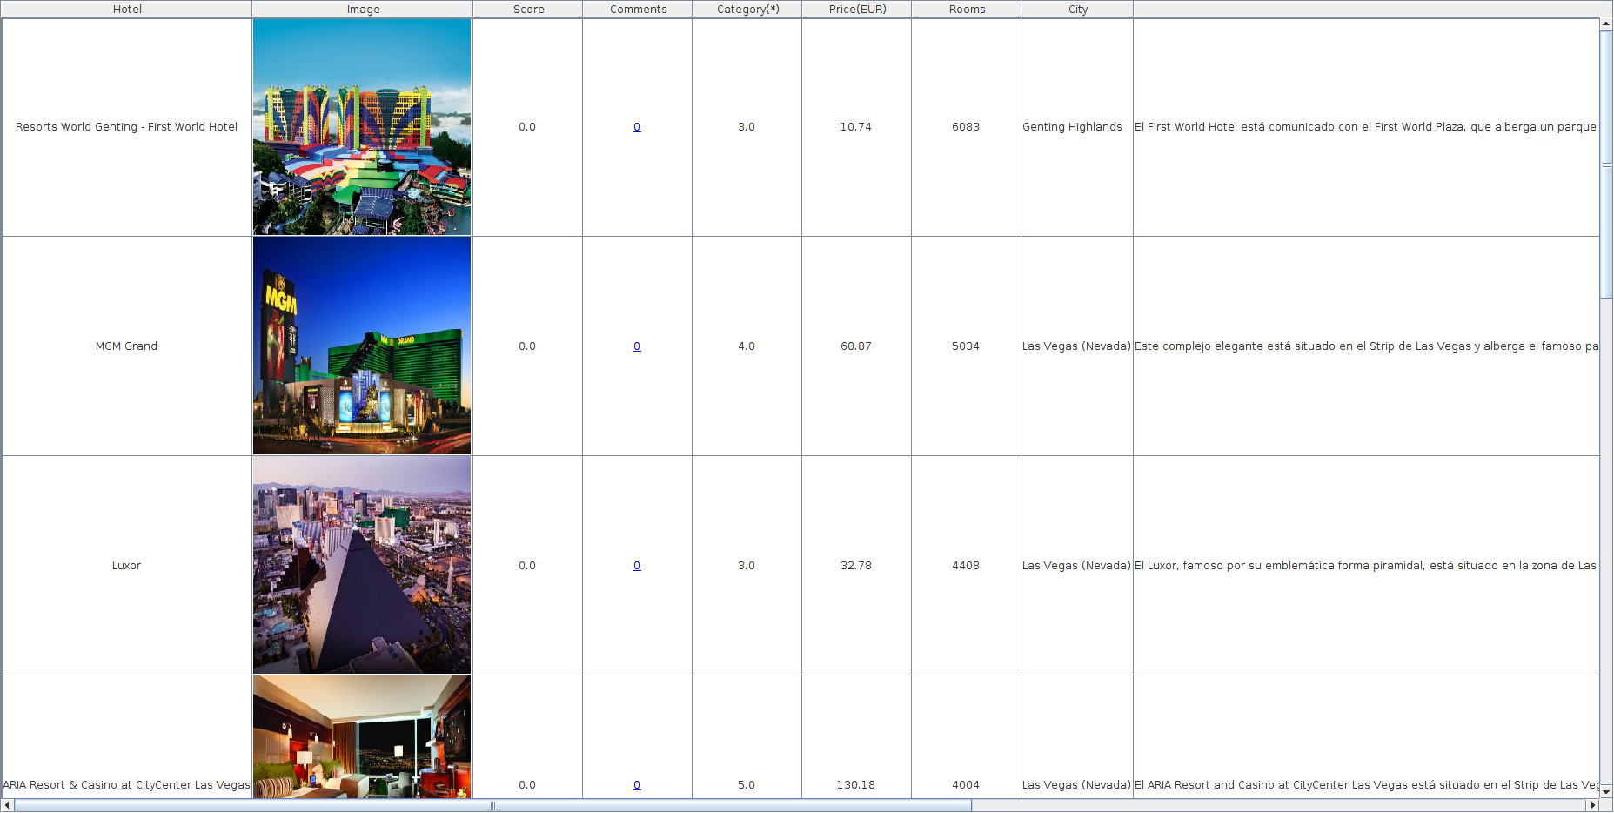

8. HOTEL ADVISOR - CREAR REVIEW HOTEL

-------------------------
1. Search Hotel
2. Advanced Search Hotel
3. Search Hotel POIs
4. Search POI Hotels
5. TOP Hotels
6. Review Hotel
7. Show User Reviews
8. Modify User Preferences
9. Logout
-------------------------
Choose Option:
6

Hotel name:
NH

Found 343 hotels:
________________________________________________________________________________
| Hotels |
|===============================================================================|
| 1 -> NH Leganes(Leganés) |
| 2 -> NH Pisa(Pisa) |
| 3 -> NH Queretaro(Querétaro) |
| 4 -> NH Logroño(Logroño) |
| 5 -> NH Linate(Peschiera Borromeo) |
| 6 -> NH Rex(Geneva) |
| 7 -> NH Siena(Siena) |
| 8 -> NH Bingen(Bingen am Rhein) |
| 9 -> NH Coatzacoalcos(Coatzacoalcos) |
| 10 -> NH Antofagasta(Antofagasta) |
| 11 -> Cottage NH(Tsaghkadzor) |
| 12 -> NH Ingolstadt(Ingolstadt) |
| 13 -> NH Magdeburg(Barleben OT Ebendorf) |
| 14 -> NH Mechelen(Mechelen) |
| 15 -> NH Weinheim(Weinheim) |
| 16 -> NH Wiesbaden(Wiesbaden) |
| 17 -> NH Erlangen(Erlangen) |
| 18 -> NH Schwerin(Schwerin) |
| 19 -> NH Deggendorf(Deggendorf) |
| 20 -> NH Barajas(Madrid) |
...
| 343 -> NH Collection Buenos Aires Centro Histórico(Buenos Aires) |

Select Hotel Id:
28

Score Location (0-10):
9

Score Cleanliness (0-10):
8

Score Confort (0-10):
7

Score Installations (0-10):
6

Score Personal (0-10):
10

Score WIFI (0-10):
9

Score Value for Money (0-10):
9

Comment:
Buen hotel en Poznan. Céntrico. Baño impecable. Me ha gustado mucho la ciudad, la recomiendo.

9. HOTEL ADVISOR - MOSTRAR REVIEWS PERSONALES
-------------------------
1. Search Hotel
2. Advanced Search Hotel
3. Search Hotel POIs
4. Search POI Hotels
5. TOP Hotels
6. Review Hotel
7. Show User Reviews
8. Modify User Preferences
9. Logout
-------------------------
Choose Option:
7

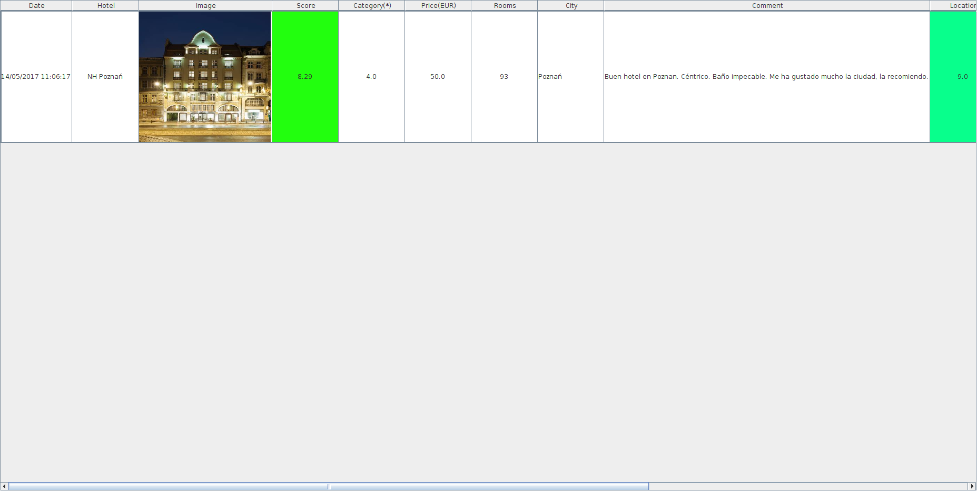

10. HOTEL ADVISOR - MODIFICAR PREFERENCIAS USUARIO

-------------------------
1. Search Hotel
2. Advanced Search Hotel
3. Search Hotel POIs
4. Search POI Hotels
5. TOP Hotels
6. Review Hotel
7. Show User Reviews
8. Modify User Preferences
9. Logout
-------------------------
Choose Option:
8

New Password [angel]:
angel

New Name [Angel]:
Angel

New Surname [Gomez]:
Gomez

New Age [55]:
55

New Email [angel.gomez@movistar.es]:
angel.gomez@movistar.es

New Language [es]:
es

New Pois Min Distance (m) [0.0]:
0

New Pois Max Distance (m) [1000.0]:
1000

New Pois Number Limit [20]:
20

New Pois Types [0]:
[0: 'ALL', 1: 'ACCOMMO_ALPINEHUT', 2: 'ACCOMMO_CAMPING', 3: 'ACCOMMO_CARAVAN', 4: 'ACCOMMO_CHALET', 5: 'ACCOMMO_HOSTEL', 6: 'ACCOMMO_HOTEL',
7: 'ACCOMMO_MOTEL', 8: 'AMENITY_COURT', 9: 'AMENITY_FIRESTATION', 11:'AMENITY_LIBRARY', 12:'AMENITY_PLAYGROUND', 13: 'AMENITY_POLICE',
14:'AMENITY_POSTOFFICE', 15:'AMENITY_PRISON', 16: 'AMENITY_PUBLICBUILDING', 17:'AMENITY_TOWNHALL', 18:'BARRIER_BLOCKS', 19:'EDUCATION_COLLEGE',
20:'EDUCATION_NURSERY', 21:'EDUCATION_SCHOOL', 22:'EDUCATION_UNIVERSITY',23:'FOOD_BAR',24:'FOOD_BIERGARTEN',25:'FOOD_CAFE',
26:'FOOD_FASTFOOD',27: 'FOOD_ICECREAM', 28:'FOOD_PUB', 29:'FOOD_RESTAURANT',30:'HEALTH_DENTIST',31:'HEALTH_DOCTORS',32:'HEALTH_HOSPITALEMERGENCY',
33:'HEALTH_HOSPITAL',34:'HEALTH_PHARMACY',35:'HEALTH_VETERINARY',36:'LANDUSE_ALLOTMENTS',37:'LANDUSE_CONIFEROUSDECIDUOUS',38:'LANDUSE_CONIFEROUS',
39:'LANDUSE_DECIDUOUS', 40:'LANDUSE_GRASS',41:'LANDUSE_HILLS',42:'LANDUSE_MILITARY',43:'LANDUSE_QUARY',44:'LANDUSE_SCRUB',45:'LANDUSE_SWAMP',
46:'MONEY_BANK',47:'MONEY_EXCHANGE',48:'POW_BAHAI',49:'POW_BUDDHIST',50:'POW_CHRISTIAN',51:'POW_HINDU',52:'POW_ISLAMIC',53:'POW_JAIN',
54:'POW_JEWISH', 55:'POW_SHINTO', 56:'POW_SIKH',58:'POW_UNKOWN',59:'POI_CAVE',60:'POI_CRANE',61:'POI_EMBASSY',62:'POI_BUNKER',63:'POI_MINE',
64:'POI_PEAK1',65:'POI_PEAK',66:'POI_CITY',67:'POI_HAMLET',68:'POI_SUBURB',69:'POI_TOWN',70:'POI_VILLAGE',71:'POI_TOWERCOMMUNICATION',72:'POI_TOWERLOOKOUT',
73:'SHOP_ALCOHOL', 74:'SHOP_BAKERY',75:'SHOP_BICYCLE',76:'SHOP_BOOK',77:'SHOP_BUTCHER',78:'SHOP_CARREPAIR',79:'SHOP_CAR',80:'SHOP_CLOTHES',
81:'SHOP_COMPUTER',82:'SHOP_CONFECTIONERY',83:'SHOP_CONVENIENCE',84:'SHOP_COPYSHOP',85:'SHOP_DEPARTMENTSTORE',86:'SHOP_DIY',87:'SHOP_FISH',
88:'SHOP_FLORIST',89:'SHOP_GARDENCENTRE',90:'SHOP_GIFT',91:'SHOP_GREENGROCER',92:'SHOP_HAIRDRESSER',93:'SHOP_HEARINGAIDS',94:'SHOP_HIFI',
95:'SHOP_JEWELRY', 96:'SHOP_KIOSK',97:'SHOP_LAUNDRETTE',98:'SHOP_MARKETPLACE',99:'SHOP_PHONE',100:'SHOP_MOTORCYCLE',101:'SHOP_MUSIC',
102:'SHOP_NEWSPAPER',103:'SHOP_PET',104:'SHOP_SHOES',105:'SHOP_SUPERMARKET',106:'SHOP_TOBACCO',107:'SHOP_TOYS',108:'SHOP_VENDINGMASCHINE',
109:'SHOP_VIDEORENTAL',110:'SPORT_ARCHERY',111:'SPORT_BASEBALL', 112:'SPORT_BASKETBALL',113:'SPORT_BOWLING',114:'SPORT_CANOE',
115:'SPORT_CRICKET',116:'SPORT_DIVING',117:'SPORT_FOOTBALL',118:'SPORT_GOLF',119:'SPORT_GYM',120:'SPORT_GYMNASIUM',121:'SPORT_CLIMBING',
122:'SPORT_HORSE',123:'SPORT_ICESKATING',124:'SPORT_LEISURECENTER',125:'SPORT_MINIATURGOLF', 126:'SPORT_MOTORRACING',127:'SPORT_SHOOTING',
128:'SPORT_SKATING',129:'SPORT_SKIINGDOWNHILL',130:'SPORT_SNOOKER',131:'SPORT_SOCCER',132:'SPORT_STADIUM',133:'SPORT_SWIMMING',
134:'SPORT_TENNIS',135:'SPORT_WATERSKI',136:'SPORT_SURFING',137:'TOURIST_ARCHAELOGICAL',138:'TOURIST_ART',139:'TOURIST_ATTRACTION',
140:'TOURIST_BATTLEFIELD',141:'TOURIST_BEACH',142:'TOURIST_CASTLE',143:'TOURIST_CASTLE2',144:'TOURIST_CINEMA',145:'TOURIST_FOUNTAIN',
146:'TOURIST_INFORMATION',147:'TOURIST_MEMORIAL',148:'TOURIST_MONUMENT',149:'TOURIST_MUSEUM',150:'TOURIST_NIGHTCLUB', 151:'TOURIST_RUINS',
152:'TOURIST_THEATRE',153:'TOURIST_THEMEPARK',156:'TOURIST_WINDMILL',157:'TOURIST_WRECK',158:'TOURIST_ZOO',159:'TRANSPORT_TERMINAL',
160:'TRANSPORT_AIRPORT',161:'TRANSPORT_BUSSTOP',162:'TRANSPORT_FUEL',163:'TRANSPORT_LIGHTHOUSE',164:'TRANSPORT_MARINA',165:'TRANSPORT_RENTALCAR',
166:'TRANSPORT_SUBWAY',167:'TRANSPORT_STATION',168:'TRANSPORT_TRAMSTOP',169:'WATER_DAM',170:'WATER_TOWER',171:'WATER_WEIR']
0

New TOP Hotels Limit [10]:
20

11. HOTEL ADVISOR – DASHBOARDS (KIBANA)

Conectarse con un navegador a http://localhost:5601

11.1 TAG CLOUD PAÍSES

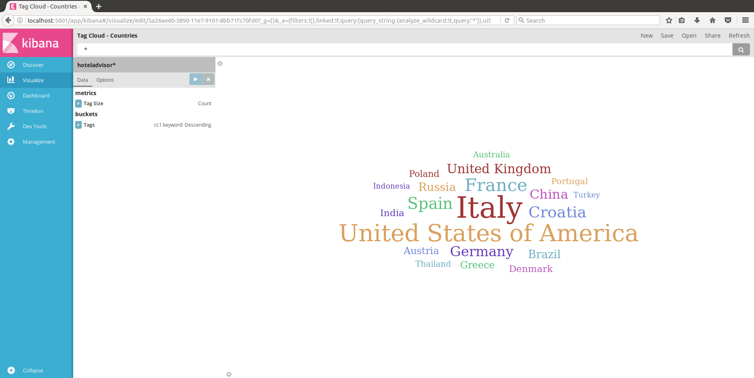

11.2 PUNTUACIÓN POR PAÍS

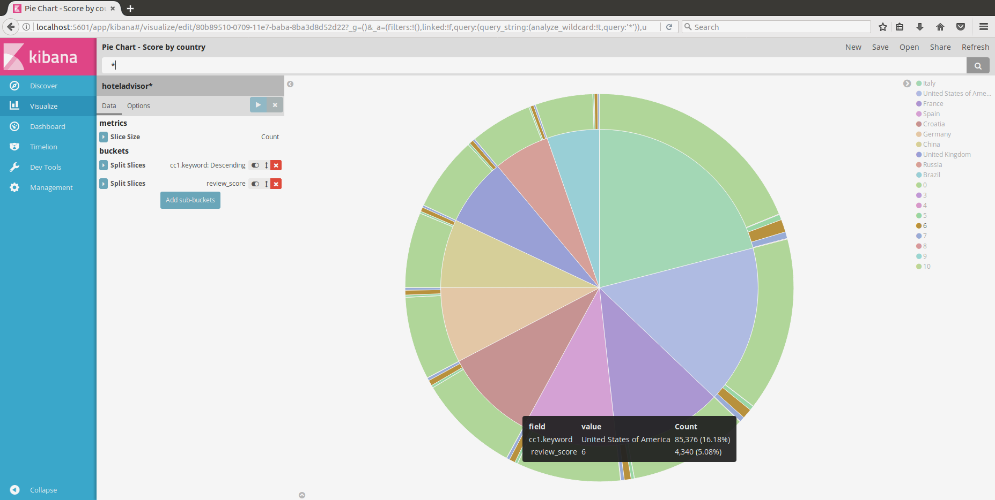

11.3 PUNTUACIÓN POR EDAD

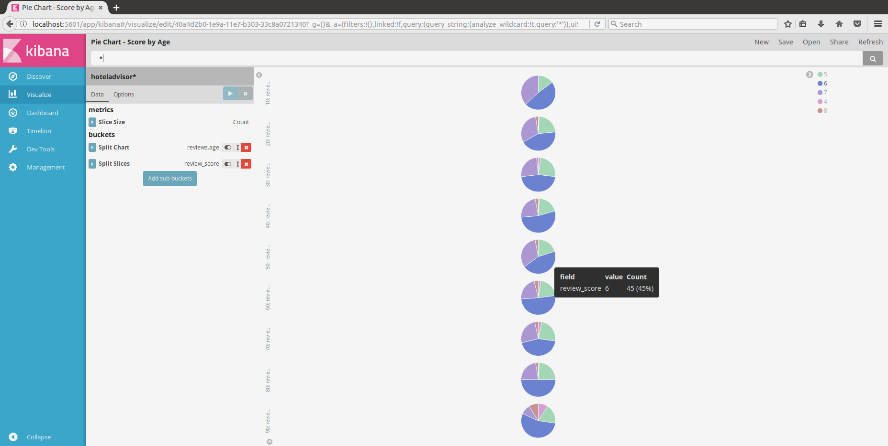

11.4 MAPA GEOGRÁFICO HOTELES

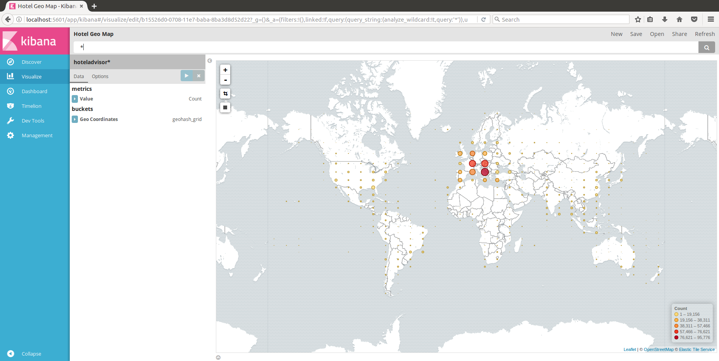

11.5 MAPA GEOGRÁFICO POIS

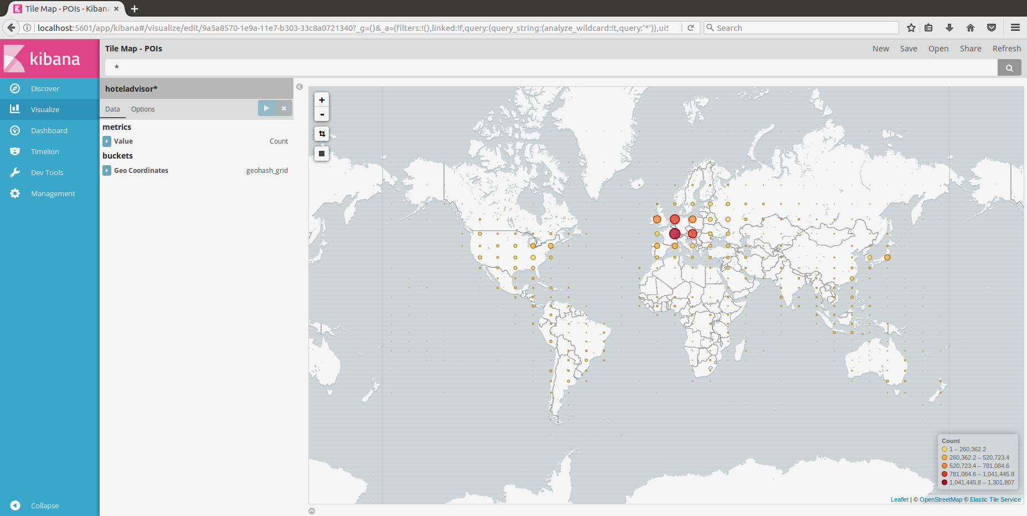

11.6 NÚMERO DE REVIEWS POR SEMANA

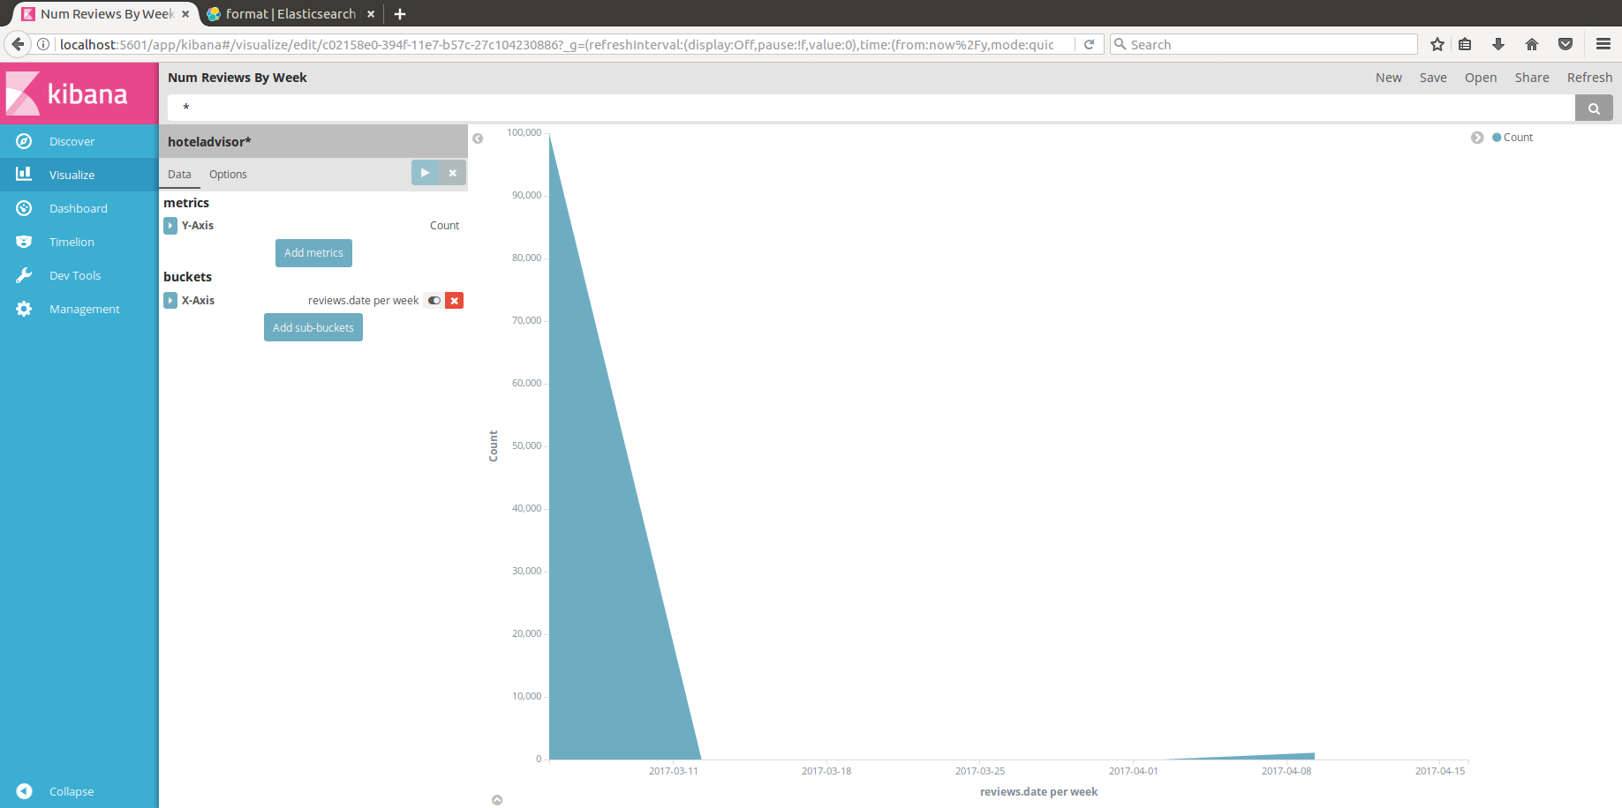

11.7 DASHBOARDS



